**Use of Local Limestone**

The abundance of local limestone rock in the Scenic Loop area provided early settlers with free building material. Whether Spanish lodges like the Menchaca house, imposing German worked stone like the Marnoch house, early farmsteads, or Grey Forest cottages, builders used this rock in a variety of architectural styles. Consistent along the Scenic Loop are the low rock walls with pillar entrances (many with planter tops), stiles in front of and behind these walls, and large gateways to specific destinations.



S. Beavin Stile in a wall on Scenic Loop Road



S. Beavin Cactus planter atop limestone wall



S. Beavin Planter column

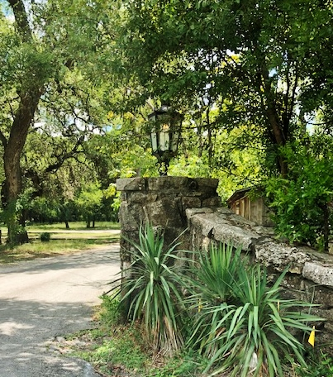

R. Neumann Original SLP Entry

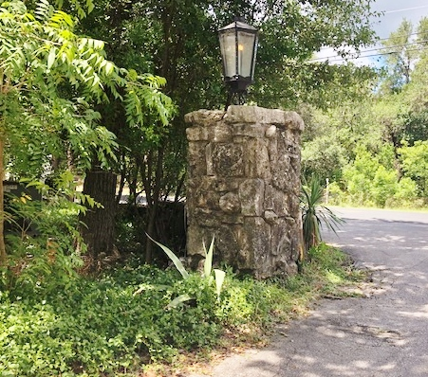

R. Neumann Original SLP Entry

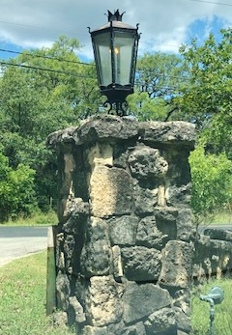

R. Neumann Original SLP Entry

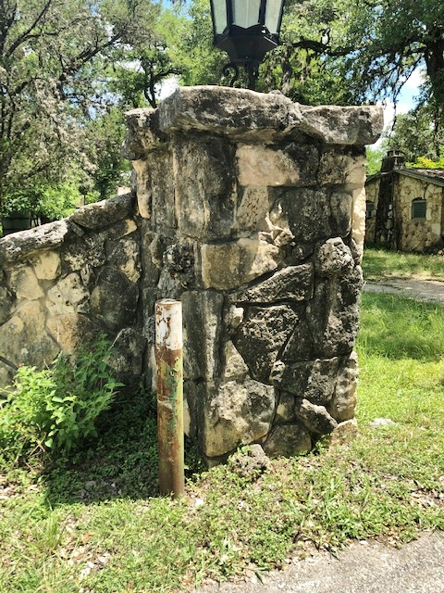

R. Neumann Original SLP Entry