Judge Robert Milton Duty

Robert Milton Duty was born in Houghton, Louisiana March 2, 1897. It is unclear what brought his family to San Antonio but he spent a portion of his youth on Leigh Avenue in what is known today as Southtown. He married Sattys Louise Reeves in Nueces County on 23 Dec 1917. That same year he had registered for service in WWI and was employed as a Clerk in the U S Supply Depot at Duncan Field. Duncan Field was an adjunct to Kelly Field near San Antonio that was formed following WW I and later incorporated into Kelly Field. In 1919 a child was born to the union but died the same day. Then in 1922 son Artis Milton Duty was born. Two years later another son, Weldon Eugene Duty was born. Then between 1924 and 1930 the marriage ended in divorce. His former wife took his two sons and remarried raising the boys in Ohio and later in Houston. Apparently Robert Duty made the best of his time by studying the law. By 1934 he had remarried to Miss Lula Martin, a school teacher, and on 22 JUN 1935 was admitted to practice law before the State Bar of Texas.

Though he was practicing law and 45 years of age, Mr. Duty was again registered to fight in the Second World War. His younger son Weldon was a pilot and died in the war. His oldest son, Artis, was a WWII tank commander and saw a continuous three month deployment in some of the worst fighting of the EuropeanTheatre.

The Duty’s lived for a time on Harding Avenue before relocating to West Hildebrand Avenue. City directories show Mr. Duty practicing law in the old Frost Bank Building and later at 304 W. Houston Street. In the very early 1960’s the Duty’s moved to the Scenic Loop Playground to a picturesque stone cottage located at 290 Hilltop Drive. They had owned the cottage since 1945. In the earlier days of Scenic Loop Playground Morningside Drive did not exist and the upland section of Hilltop where the Duty’s lived was rather remote and isolated. They embarked on an effort to purchase a large portion of
that area. The following timeline and plat map indicates the success of the venture.
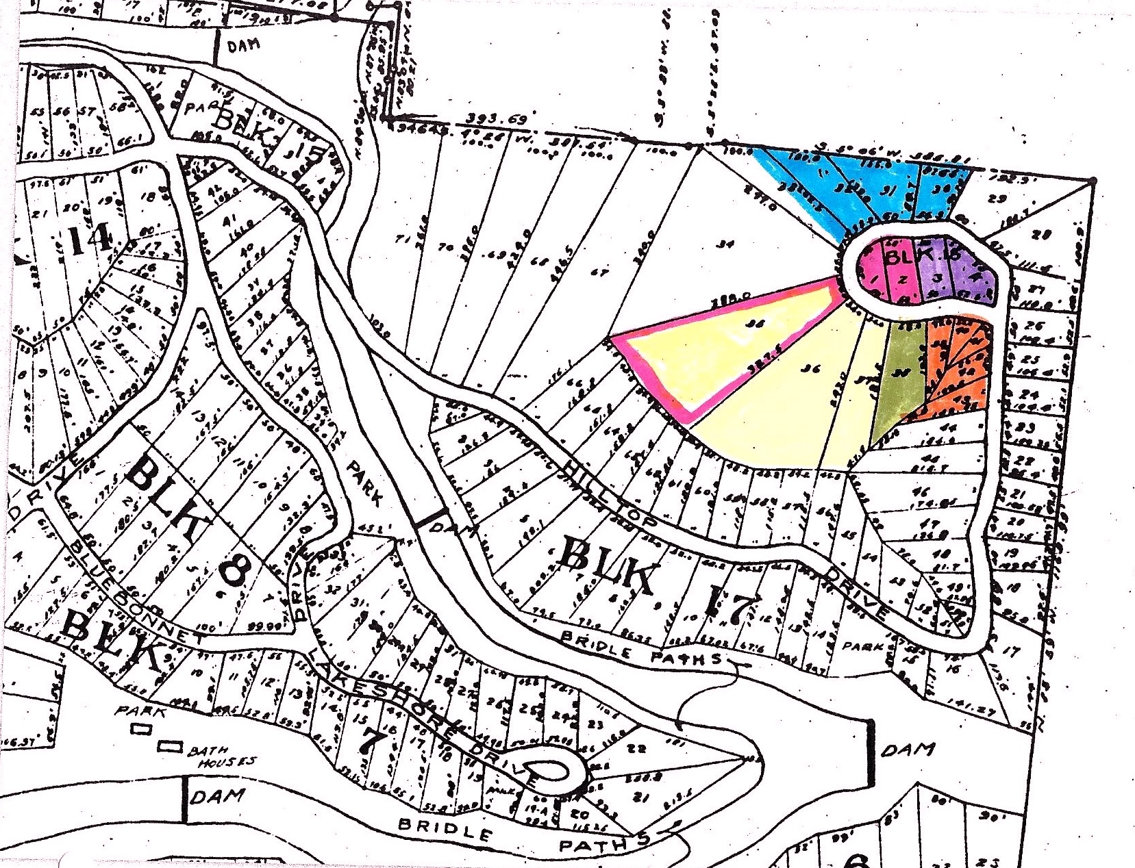

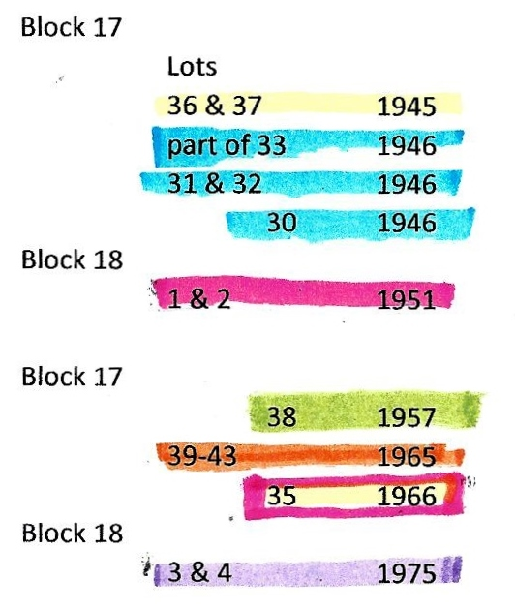

As talks began to gel in the early 60’s about possibly incorporating Grey Forest, Robert Duty was recruited to repeatedly travel to Austin to research and file paperwork in the effort to form a city. Once the City was incorporated he served for many years as the first Municipal Court Judge. During his residency in the area he was called upon by many citizens to witness documents and draw-up wills and to officiate in real estate transactions and other legal matters. Judge Duty died in 1982 and Mrs. Duty continued to live on at Hilltop for another decade until her death in 1992.

You will note that the map denotes this property at Hillside. This was prior to the development of Morningside drive and Beck-Cliff Park which connected Morningside to Hilltop. At that time the loop at the top of Hilltop became Morningside.

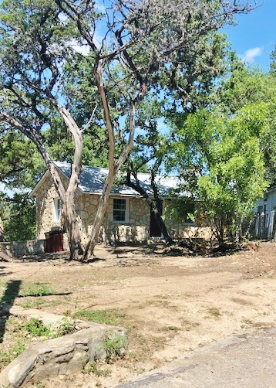
Robert & Lula Duty Cottage, formerly 290 Hilltop Dr. Scenic Loop Playground

