Marnoch House - Scenic Loop

This unique limestone house is a rare edifice in this part of Texas. Built in 1859 by Dr. George Marnoch, MD a Scottish immigrant, the home is influenced predominately by German and Scottish architectural styles, typical of structures in Marnoch’s native Scotland. Dr. Marnoch purchase approximately 1500 acres from Francois Giraud, an early San Antonio Mayor, and the town of Helotes actually began on Marnoch land. San Antonio architect John M. Fries was hired to design and construct the home but Fries was engaged constructing the Menger Hotel so Marnoch had to wait. The interior wood was hauled from the port of Indianola by ox cart. Some of the interior finish items were shipped from Scotland and England. George’s son, Gabriel, became a famous doctor, not as much for his physician’s skills, but as that of a naturalist. He discovered the Balcones Fault and the “barking frog”, a rare native to this area. Hoof prints on the staircase are said to be the results of bringing the horses upstairs during Comanche raids. A Palo Alto College student conducting a small town history, as well as the Helotes government website, provided some of this detail.

This property was later owned by Mrs. & Mrs. Charles Brown, Jr. and used to be the location of the Helotes Echo publication. Lucy Brown, a long-time resident of Helotes, related many stories of the town’s early days to a fourth grade elementary class. These were later transcribed in “The Lucy Story “, but copies are difficult to find.

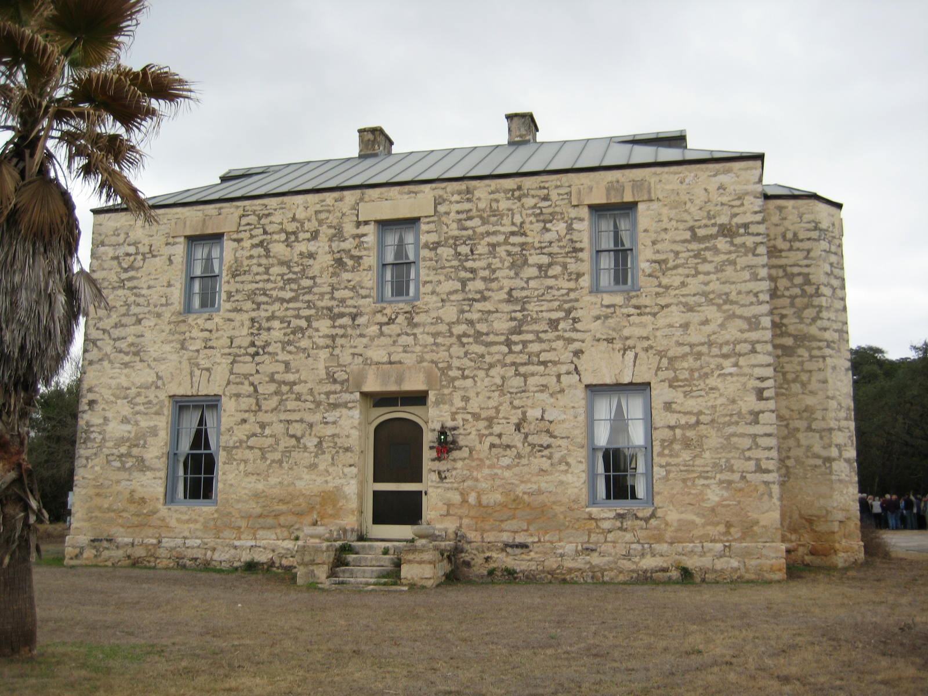
Marnoch House – front view

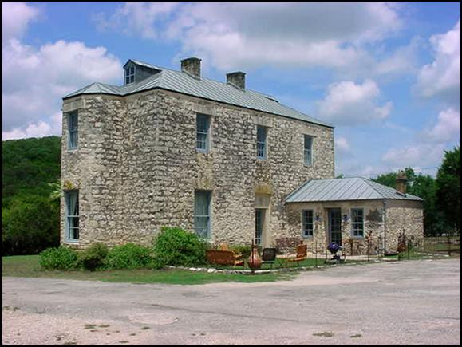
Marnoch House – rear view

