John Conrad Beckmann
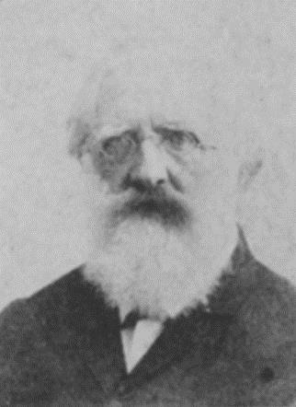 (Johann “John” Conrad Beckmann 1815-1907)
A native of Westphalia, John Conrad Beckmann was born June 13, 1815 in Rulle. He apprenticed in woodworking, locksmithing and blacksmithing before immigrating to America. After a short time in New York, Baltimore and Cincinnati he returned to Europe, to Switzerland to claim his fiancé, Regina Mueller. They sailed for America where they were wed in New York, travelled to New Orleans and in 1846 arrived in San Antonio, Texas where they would make their home for the rest of their lives.
Beckmann became a substantial citizen in the heavily Germanic San Antonio business and social circles. He was a founder of the Masonic Lodge, The Turnverein, the German-English School, the Casino Club, the Beethoven Mannechor and other societies and was a singer in the Teutonia Society.
He quickly became known for his artistry in wrought iron and smithing. The US Government hired Beckmann to set up the smithing operation in the Alamo as a part of its pre-Civil War refurbishment. In the early 1850’s Beckmann purchased 320 acres in the Canon de los Helotes, land divided by the Helotes Creek. The area was wild and largely uninhabited at that time and Indian depredations were still common. A portion of the Beckmann property near present-day Low Road was level, arable land and the Beckmann’s hired a Mexican family to tend the farm on “halves.” At that same time Mrs. Beckmann was reportedly homesick for Switzerland and so her husband built her a “Swiss Chalet” on Beckmann Hill near the intersection of present day Scenic Loop and Menchaca Roads. Photos indicate that the “Chalet” was nothing more than a hunting shack indicating that one or both of the Beckmann’s had a sense of humor. Sadly, the Mexican caretakers were later massacred in an Indian raid. Not even the children were spared. It is reported that one child was found pinned to the floor with knives.
Undeterred, the Beckmann’s built a board and batten structure to replace the “chalet” and continued to visit their country place and use it for hunting and entertaining family and friends.
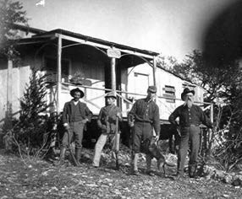
House on Beckmann Hill above Scenic Loop Road
In San Antonio the Beckmann’s first home was located on Crocket Street. Later they built a small home at 110 Casino Street near Mr. Beckmann’s blacksmith shop which fronted on Commerce Street.
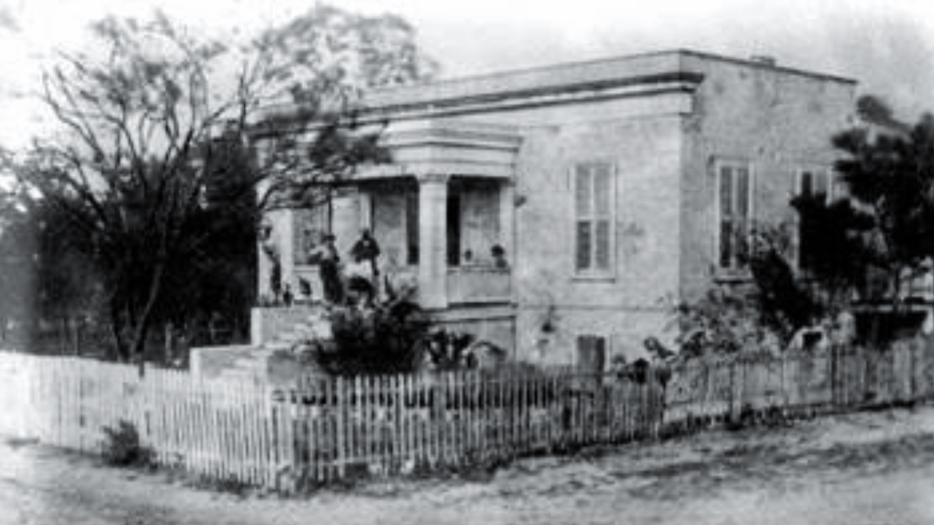
Beckmann House at 116 Casino St. Today the site is a parking lot behind Casa Rio Restaurant.

Within a few years they built a larger house at 116 Casino Street which backed-up to the San Antonio River. John Conrad Beckmann died in 1907 and was survived by his two sons John and Albert. Of the Beckmann’s seven children most were lost to cholera.
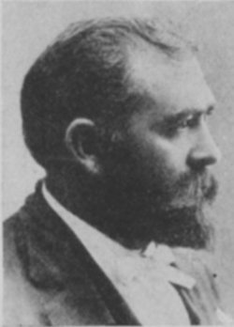 Albert Felix Beckmann (1855-1900)
Albert F. Beckmann married Marie Guenther of the local milling family and became an architect completing his studies in Germany. He is perhaps best known for building the original Joske’s Store as well as many government buildings throughout Texas and Northern Mexico. Toward the end of his career he re-teamed with his former partner James Wahrenberger to be the local architects on the construction of the Lone Star Brewery in 1895. Albert died in 1900.
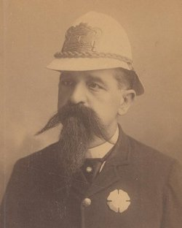 John A. Beckmann (1850-1912)
John Beckmann, Albert’s older brother, was a City of San Antonio policeman. He died in 1912.
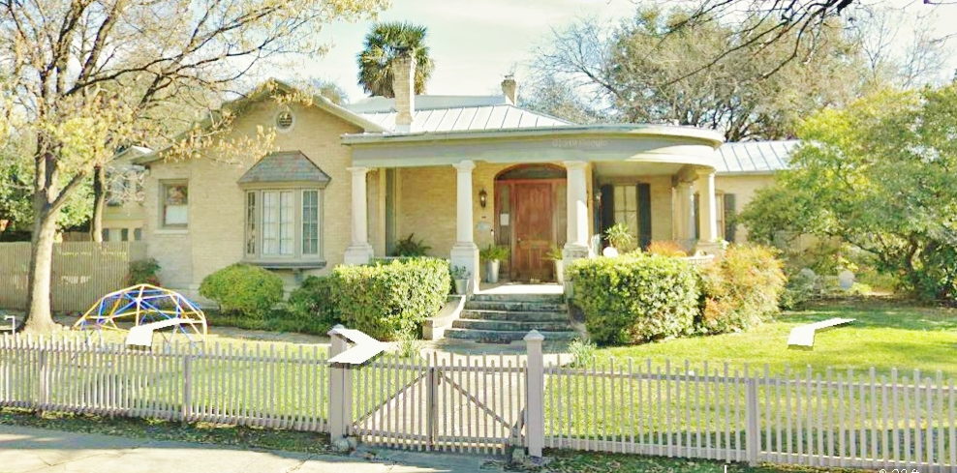
This home was designed and constructed by Albert Felix Beckmann in the King William neighborhood. The original address was 529 Madison Street. With the rising prominence of his wife’s family the front entrance of the house was remodeled to face Guenther Street where the address was changed to 222. Following Albert’s death the home was occupied by his son, Adolph, who was president and general manager of C. H. Guenther & Son/Pioneer Mills for many decades.
With Albert’s early death in 1900 his son Adolph assumed responsibility for his mother and siblings. He attended San Antonio’s German-English School which his family had founded and continued his training at Washington University in Saint Louis, Missouri. Adolph served in executive capacities with the Guenther Mills for nearly fifty years.
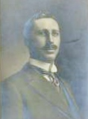Adolph Guenther Beckmann (1887-1954)
While serving as Duke in the Festival of Flowers Coronation in 1911 & 1912 his Duchess was a Miss Mary Milby Giles, the daughter of well-known architect Alfred Giles. The two were married in April of 1915.
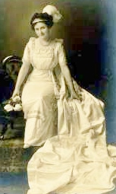 Mary Milby Giles, Duchess of the Festival of Flowers, 1911 & 12.
Descendants of the family developed a small portion of land at the southern end of Scenic Loop Playground along Morningside Drive near Menchaca and the neighborhood is known as Beck-Cliff Park.
It is believed that several of Beckmann’s brothers from Germany had visited New York with him and made their way to Central Texas. At least two Beckmann family members acquired land northwest of San Antonio near the Leon Creek. Railroad maps began to notate the area as Beckmann and eventually a flag stop named Beckmann was built along the tracks of the Texas and New Orleans Railroad. The first industry there was quarrying, a business which continues in the area today. Though the hamlet of Beckmann is all but forgotten the location is well-known today as the home of the Fiesta Texas theme park, La Cantera Mall and the Rim Shopping Center.
An interesting side-note to the life of John Conrad Beckmann has to do with his relationship to the French-born Texas artist Jean Louis Theodore Gentilz. Gentilz was the son of Pierre Louis Gentilz a successful Parisian carriage manufacturer who wanted his son to follow him in his business. Instead, young Theodore signed on with Henri Castro to come to America as a surveyor and artist in Castro’s colonizing scheme where he surveyed and helped to design Castroville, Quihi, New Fountain and other hamlets in Castro’s Colony. Along the way Gentilz documented in paintings the history of the area. But back home in Paris his father fumed that Theodore was wasting his time in Texas and especially worried about his son’s decision to become an artist. The Beckmann family asked Gentilz to paint a portrait of John Conrad Beckmann. Beckmann, a busy man, thought that sitting for the young artist was a great waste of his time. However, Beckmann was so pleased with the portrait that he wrote a letter to Pierre Louis Gentilz in Paris praising his son’s talents. The letter apparently changed the father’s mind about Theodore’s vocation and the two were reconciled as a result of Beckmann’s praise.

