Don Juan Antonio Ximenes 1810-1877
Not far to the southwest of the ever-growing development of Cantera Hills and The Canyons of Scenic Loop Subdivisions lies the remnants of the Huntress family’s Guajolote Ranch. The earlier incarnation of the Huntress Ranch was Rancho Diana at the end of Menchaca Road however the Huntress family sold that property in the early 1950’s and moved farther north where they purchased a portion of Edgar Basse’s large Black Buck Ranch and developed water features and built modern ranch housing. The land this ranch is located on was once awarded to a local San Antonio man for his participation in the Battle of Bexar in 1835 wherein a small Texas Army routed General Martin Perfecto de Cos (Santa Anna’s brother-in-law) from San Antonio de Bexar and drove him from Texas. It was a particularly difficult battle that quickly turned into fierce house-to-house fighting before it was over. San Antonio born Juan Antonio Ximenes was a part of the storming force that fought in that battle. In appreciation for his service he was awarded a Land Grant of 640 acres on Panales Creek, a tributary of the Helotes Creek in 1861 where the Huntress Ranch is located today, about a mile or so west of the intersection of Babcock and Scenic Loop Roads.

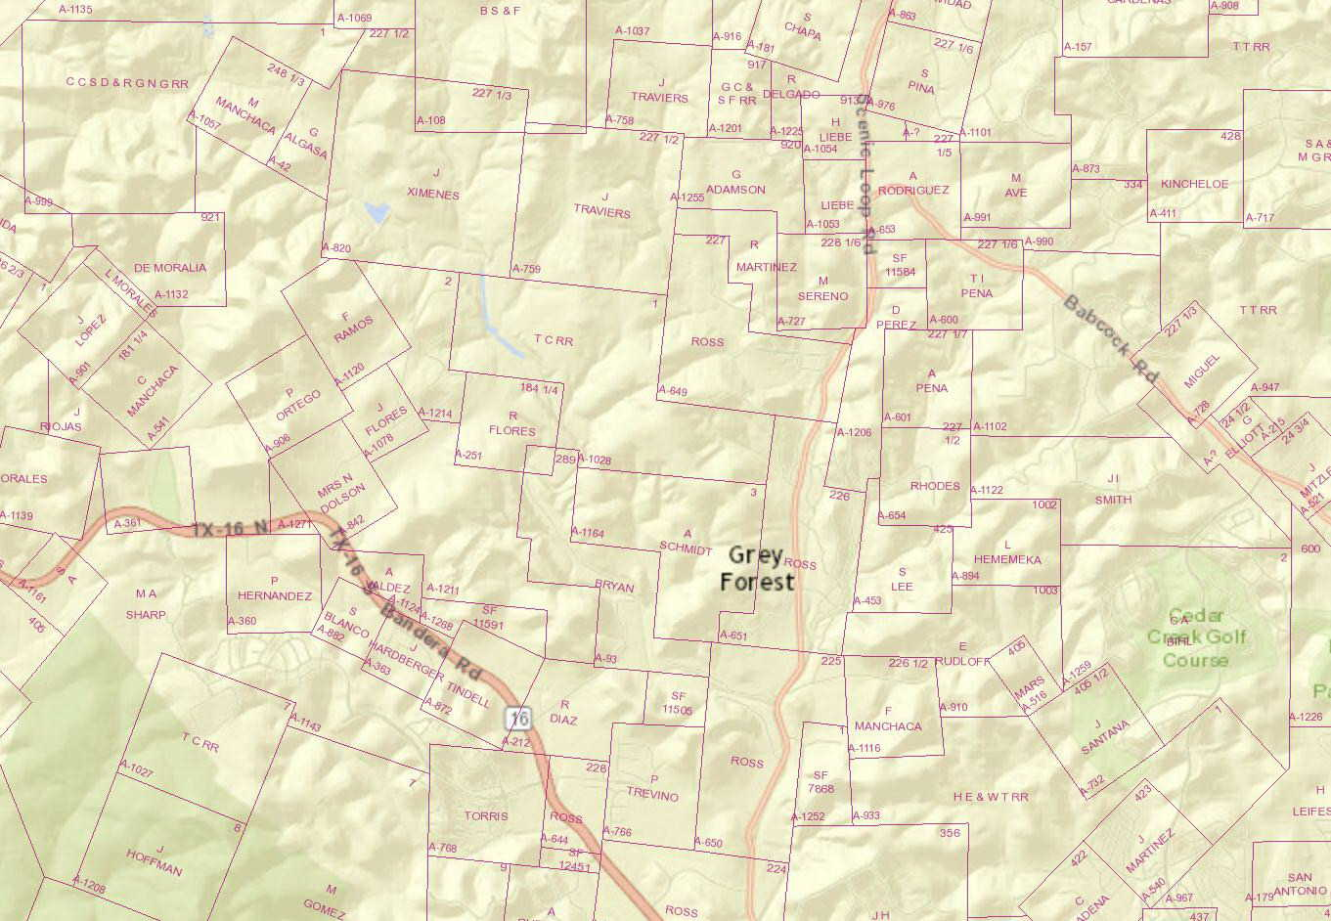

Ximenes led an interesting life and was much celebrated in 19th century San Antonio. He was not only an army veteran but would go on to serve as a ranger. During his lifetime he fought for and witnessed the creation of the Republic of Texas as well as the annexation of Texas to the United States. His father donated all of his cattle to the cause of early Texas and he fought alongside his two brothers under Colonel Juan N. Seguin. His brother Damacio died at the Battle of the Alamo. In addition to his land grant he is remembered with an historic pink granite marker on Colorado Street near San Fernando Cemetery #1 where he is buried.

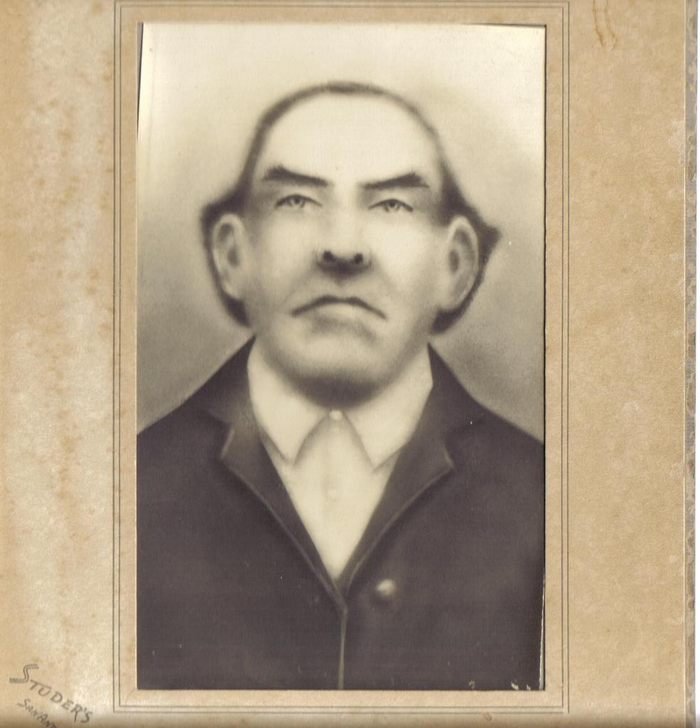
Don Juan Antonio Ximenes 1810-1877

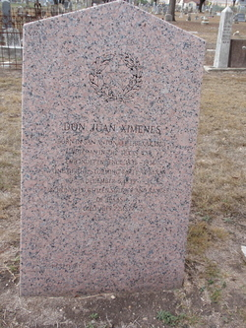
Marker located on Colorado Street near San Fernando Cemetery #1 where Don Juan Antonio Ximenes is buried.

He was born in San Antonio de Bexar in 1810 to Juan Francisco Ximenes and Teodora Rodriguez. He was raised on lands where one of the early incarnations of Mission San Antonio de Valero once stood on the outskirts of Bexar. Because of marauding Indians who frequently stole cattle and horses from his ranch Juan Francisco Ximenes was given a special dispensation from the mission priest to observe mass in a small chapel he had constructed inside his house. When the Mission was ordered secularized by Spain the priest is supposed to have given paintings, statuary and the large crucifix from the Mission church to Ximenes. He is said to have stood these items around the walls of his home chapel until, in 1813, shortly after Juan Antonio Ximenes was born he constructed a free-standing chapel and installed the former Mission items therein.

Though the chapel was never consecrated by the Roman Catholic Church it has developed a legendary reputation for healing and other miracles and many myths and legends have grown-up around the tiny shrine. In 1927 the wooden structure caught fire and burned though the sacred items were saved such as the crucifix. The building was rebuilt of stone and plaster in 1927 and it is this 26 x 16 foot building which still stands today and may be visited.

The chapel was once scheduled for demolition under Urban Renewal in the 1960’s but The San Antonio Historic Preservation office joined by the San Antonio Conservation Society as well as then U. S. Representative Henry B. Gonzales prevented its destruction. In 1980 it was listed on the National Register of Historic Places. Many historians call attention to the “fact” that the chapel sits on land that was once the Alamo. This is misinformation. The chapel sits on one of the several sites occupied by Mission San Antonio de Valero which ultimately moved to the site East of the San Antonio River in what is today downtown San Antonio, Texas and because of some nearby Cottonwood trees became known as “The Alamo.” It is generally believed that the present-day “Alamo” which was built in 1744 and which was ordered secularized by the Spanish government in 1793 is the source of the crucifix and other sanctuary items that originally came from Spain and once furnished or were intended to furnish the roofless Alamo sanctuary. Some Ximenes family legacies say that the religious items were transferred to San Fernando Cathedral and that Ximenes rescued them from a fire there and was given claim to them. It is thought that the five foot crucifix originated in Spain and was quite ancient before coming to the New World. It has hung in the Ximenes Chapel for over 210 years.

The tiny shrine is located at 115 Ruiz Street (Now 47 Haven for Hope Way) near Interstate 10 in the downtown San Antonio area. It is still privately owned by the Rodriguez family who are descendants of Don Juan Antonio Ximenes.

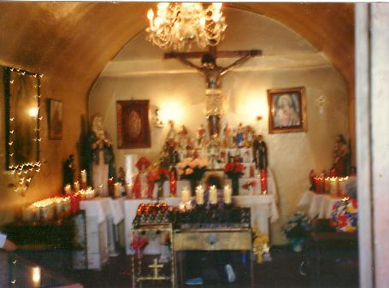
Interior of Ximenes Chapel

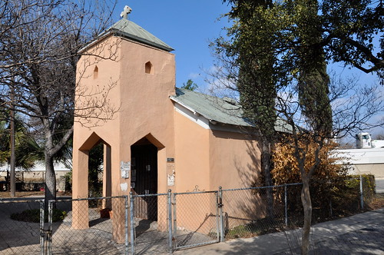
Exterior photo of Ximenes Chapel located at 47 Haven For Hope Way.

Land Grant documents for Don Juan Antonio Ximenes:
