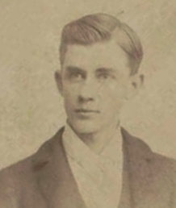
Dabney Dade Rayfield 1906-2002

Dade Rayfield lived in a rock house on Upper Green Loop near the top of McNeel Park. He was a quiet, unassuming man whose demeanor belied his background and many accomplishments. After college graduation he began his career as a reporter for several news publications before entering the military, beginning in the Army and later switching to the Air Force. In World War II he was involved in Europe and France in the Northern France, Normandy, Rhineland, Ardennes Camps and Central European Campaigns. Following the war he was stationed with Air Transport Command at Mather Field, California; Pacific Air Command; Central Division Military Air Transport, Kelly AFB; Headquarters Air Training Command, Randolph AFB; 300th Support Squadron, Randolph AFB; 3275 Technical Training Group, Lackland AFB; Headquarters Far East AF Combat Cargo Command, and finally in Korea during the Korean Conflict.
He was the recipient of many ribbons, awards, citations, medals and commendations but he was perhaps proudest of the recognition he received for his press and photographic coverage of the Korean Conflict. Many of his stories and photographs were published in the major periodicals of the day including TIME, NEWSWEEK and LIFE magazines. He continued to be published late into his life.
In 1960 he moved to Mc Neel Park and lived on property first purchased there by San Antonio physician John William Goode. He devoted much of his time in retirement to wildlife photography, spending hours in deer blinds awaiting the perfect shot. He also conducted photo sessions on a regular basis at the Gallagher Ranch near San Geronimo. His home was a virtual photographic museum. Not long after moving to the Scenic Loop he met Lucy and Charles Brown and for many years was the official/unofficial staff photographer of THE HELOTES ECHO.
Declining health forced him to give up his country home in the last ten years of his life but he lived to see 96 years of age before passing away in San Antonio in 2002.

