Comanche Creek Irrigation Company
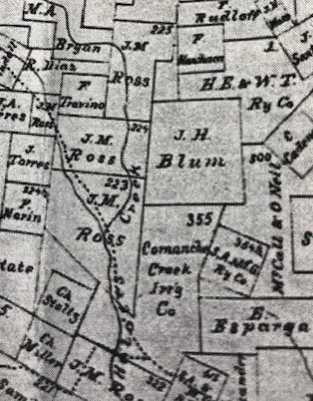

To the south of the 640 acre tract patented to Johann Blum lies another 640 acre tract which has an interesting history. In a special act of the Texas Legislature land was given to a Corporation in 1875 in payment for the construction of irrigation ditches and navigable canals. Because of his demonstrated expertise in constructing a stone acequia on the magnificent ranch he built for Santa Ana near the San Geronimo Creek about 1834, Irish master mason Peter Gallagher created a company known as the Comanche Creek Irrigation Company.
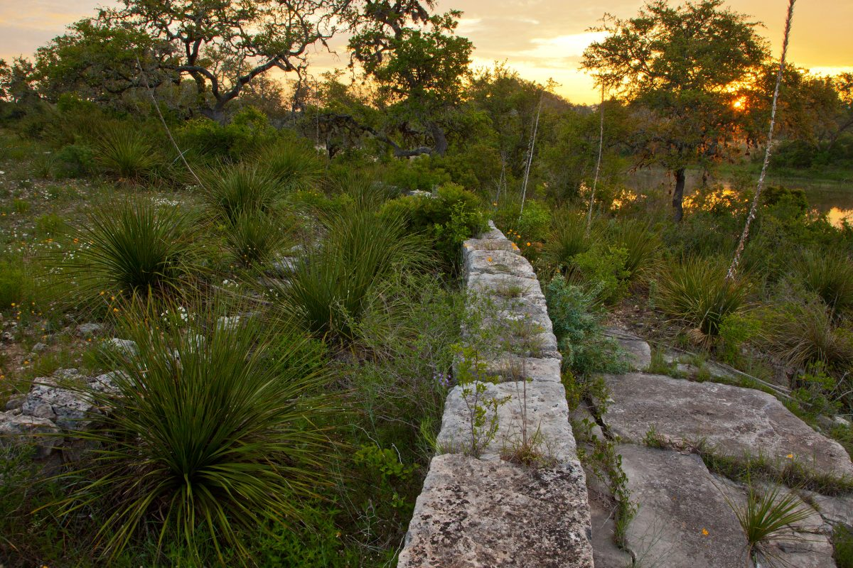
185 year old stone acequia on the Peter Gallagher Ranch at San Geronimo, Texas

He served as the company president. The 640 acre tract in the Helotes Creek Valley was payment for work done in Pecos County Texas for the State. The Comanche Creek Irrigation Company sold the entire tract to William Harvey “Willie” Maverick, son of Samuel Augustus Maverick. Maverick was a well-known San Antonio land investor/developer.
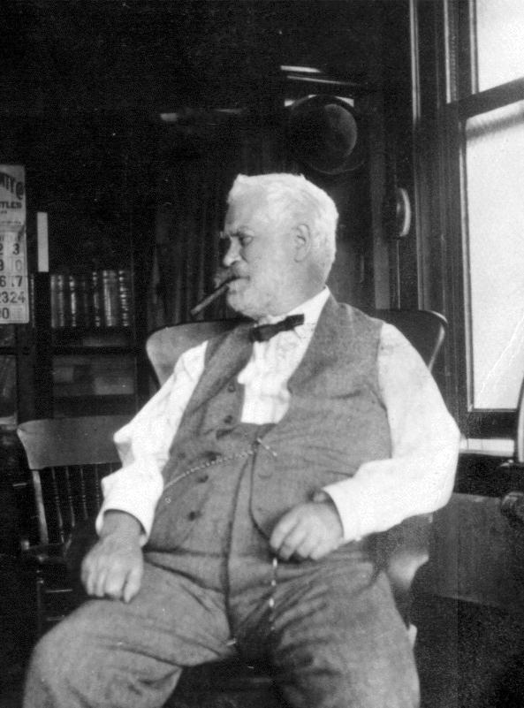 William Harvey “Willie” Maverick 1847-1923

Comanche Springs was a six artesian spring aquifer arising in the Chihuahuan desert near Fort Stockton, The Jumano and Comanche peoples knew the springs as “Awache” which means wide water. The plentiful, or so it seemed, water was part of the Edwards Aquifer and enterprising agricultural interests convinced the State of Texas to build a series of canals and ditches to irrigate 6-7,000 acres in Pecos County. The Comanche Creek Irrigation Company was formed to direct the project which was a major success. Sadly, mismanagement and a lack of understanding of the fragility of what seemed like a limitless resource led to the Comanche Springs going dry. For nearly a century, however, it allowed farmers to turn arid land into productive arable land and generated agricultural productivity for the people of that section.
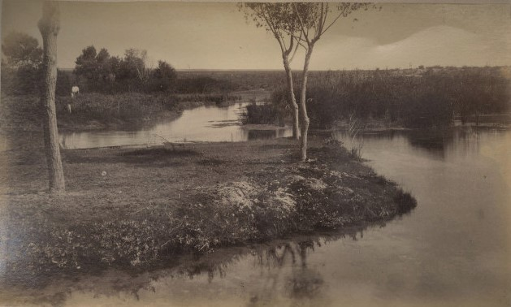 Comanche Springs
Perhaps the best known victim of the Pecos County water crisis is the esteemed Pecos Cantaloupe, a vegetable that is often mistaken for a fruit. Something about the desert climate in the area produces an exceptionally fragrant and sweet melon. A gentleman by the name of Todd began planting the orange fleshed melons over a century ago and he hawked them to the Texas and Pacific Railroad that passed through the region. Many of the transcontinental travelers had never before tasted a cantaloupe and an industry was born. Orders began to pour-in from all over the country.
Sadly, the planted cantaloupe acreage which was once over 2,000 acres has dwindled to just a little over 200 acres. Due to increased costs for water driven largely by oil and gas interest that are actively working the area as well as to the need for large numbers of migrant workers to tend and harvest the melons, farmers, many who now receive royalty checks from oil and gas, are no longer planting melons. It seems the once thriving melon business is going the way of Comanche Springs.

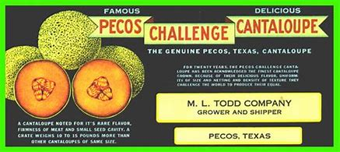

Documents surrounding the 640 acre tract sold to William H. Maverick:


  

