Clair Eugene Cheney (Col. Cheney)
Born 12 Jan 1889 at Greene, Iowa
Married Mabel Elizabeth Knox, 22 Dec 1911 in Butler, Iowa
Mrs. Cheney was an artist specializing in Hill Country landscapes.
2 sons, Harold Knox Cheney, 1913-2001 and Ralph Eugene Cheney, 1916-1997
Cheney began farming and then opened a garage in Iowa. He enlisted and became a pilot in 1917. Following the war he became an itinerant pilot flying for oil companies and aerial mapping companies. He is well-known as an early “barnstormer.” He was the head pilot for a time for Edgar Tobin Aerial mapping in San Antonio where he participated in the development of major breakthroughs in aerial photography.. He served his country again in World War II.
He moved to McNeel Park in 1931, one of the earliest residents, and built a house where the Tagliarino’s now live on Lower Green (Greenhill) The rock for the house was collected in the hills above and brought to the site by donkey and cart. The Tagliarinos bought the house from Cheney.
Mabel died in 1965 and the widowed Col. Cheney moved to San Diego in 1968 to be close to his son Harold who was a test pilot there. Son Ralph attended Texas A & M and was a career veteran of the US Navy retiring as a Commander..
Cheney married a second time in November of 1970 to Irene N. Johnson. The bride was 73 and the groom was 81 years of age.
Col. Cheney died in June of 1980.
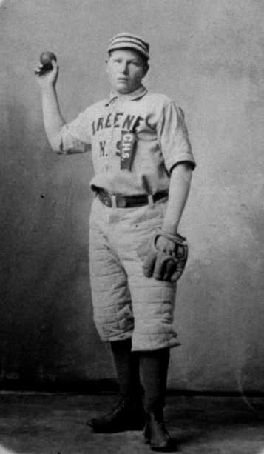
Clair Eugene Cheney, 1905

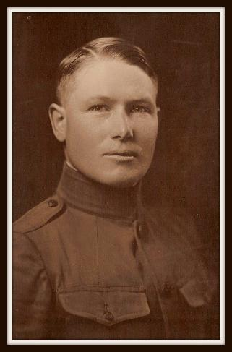
Clair Eugene Cheney, 1917, WWII
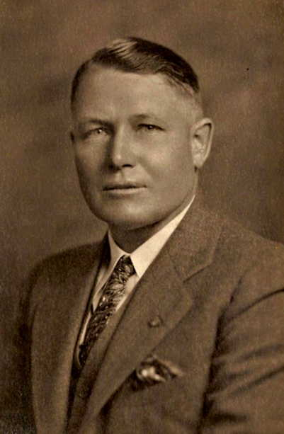
Maj. Clair E. Cheney, 1929

