Charles Xavier Gutzeit
Mr. Gutzeit was born in 1863 in San Antonio, Texas to Francois Arsine and Agatha Ketter Gutzeit, natives of Alsace Lorraine who came to Texas with Henri Castro’s colonists. The elder Gutzeit was a vegetable dealer who raised his large family on Quarry Street near the edge of town where the father and older brothers had large vegetable gardens.
Charles Xavier Gutzeit owned a plumbing business (West & Gutzeit)in San Antonio as well as other business interests. He was a partner in the Toll Road to Medina Lake, held a U S patent on a non-refillable bottle and he owned significant property in the Helotes Canyon. In the early Twentieth Century Gutzeit served as Bexar County Commissioner for Precinct 2 and probably acquired his Scenic Loop properties around that time. In the late 1920’s he sold portions of his property on the West side of Scenic Loop to J. S. Mc Neel for the formation of Scenic Loop Estates/McNeel Park and, likewise, on the East side of Scenic Loop Road he sold land to E. N. Requa for the development of Scenic Loop Playground.
Mr. Gutzeit and his wife, Melanie, never lived on their country properties. Mr. Gutsiest died at his home at 615 Maverick Street in San Antonio in 1947 at the age of 84.
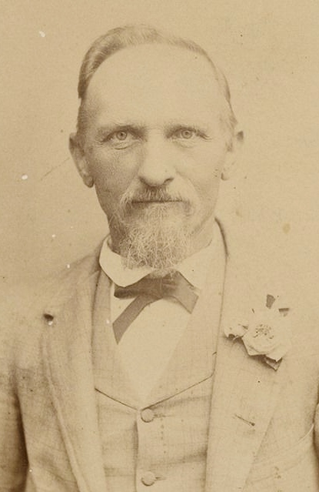
Francois Arsine Gutzeit, father of Charles Xavier Gutzeit. The father was a native of Alsace Lorraine.

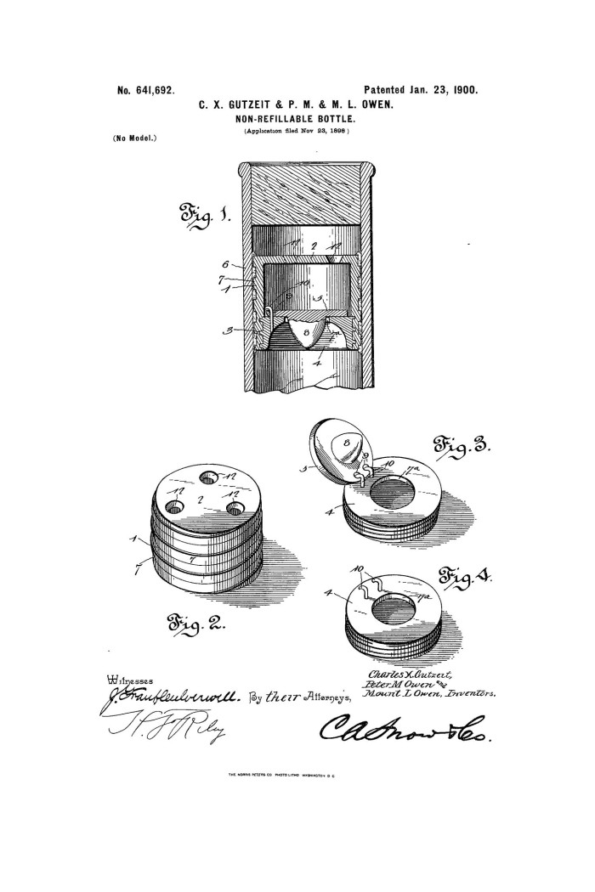
U S Patent held by Charles X. Gutzeit for a non-refillable bottle.

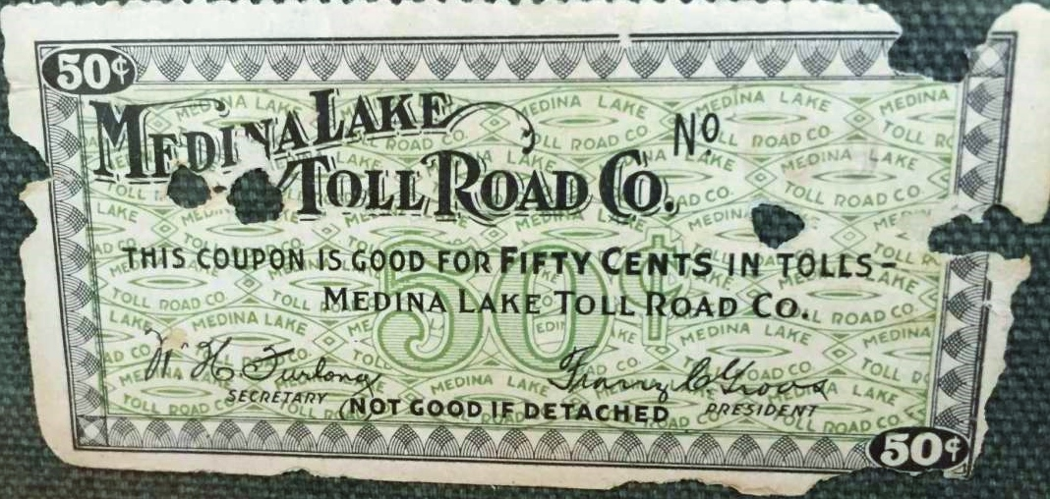
At the beginning of the 1920’s a group of San Antonio businessmen set out to simplify the long, bumpy, dusty, arduous journey between San Antonio and the newly constructed Medina Lake. They built a well- drained, graded and paved toll road that significantly reduced the time to reach the lake. While it increased the numbers of visitors to the Lake it virtually killed the rental cabin business there. Coupons like the one above were exchanged with an organ grinder’s monkey in a hat who would take tickets from road users to the delight of children making the journey.

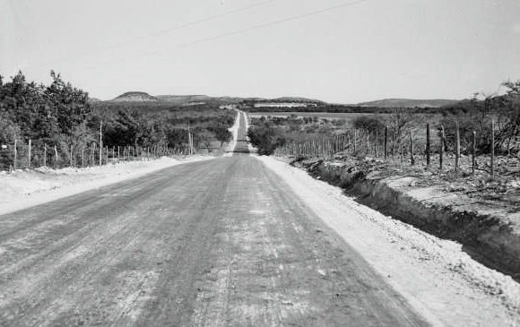
Looking westward on the Medina Lake Toll Road. The original road was later paved by the State in 1961 and became #1283. Another toll road known as the Highland Toll Road also connected Hwy 16 with the lake. That roadway would later be paved by the State as Park Road 37.

